Final Project Report — Programming for AI
University Name: National University of Computer & Emerging Sciences – Karachi Campus
Course: Programming for AI
Section: BAI-3C
Project Title: Gin Rummy AI: A Pygame Card Game with Random Forest Decision Models
Submitted By: Muhammad Noman Kamran / 25k-0110
Muhammad Kashif Khan / 25k-0018
Manaam Siddiqui / 25k-0135
Submitted To: ______________________
Date: ______________________

Abstract
Gin Rummy AI is a two-player card game written in Python with a Pygame interface, where one person plays against a computer opponent. The opponent does not rely only on hand-written rules. Its three main choices (where to draw from, which card to throw away, and when to knock) are supported by Random Forest classifiers. The forests and the ID3 trees inside them are written from scratch with NumPy. We trained them on three datasets that we produced ourselves by simulating Gin Rummy hands. In 1,000 simulated games per opponent, the AI won 99.9% of games against a random player and 52.6% against a greedy deadwood-minimising player.

1. Introduction
Gin Rummy is a card game for two players. Each player tries to arrange the cards in hand into melds, which are sets of the same number or runs of consecutive cards in one suit. Cards left outside melds are called deadwood, and the aim is to keep their total value small. A good game depends on three choices that come up again and again: take the top discard or draw from the deck, decide which card to throw, and decide whether to knock now or play on. A beginner usually makes these choices by guesswork.
This project builds a complete Gin Rummy game with a graphical interface and gives it a computer opponent whose decisions are informed by trained machine learning models. Because no ready-made dataset matched our simplified rules, we generated our own training data from the game logic. The finished AI is then compared with simple baseline players, so that its strength is measured instead of assumed.

2. Objectives
- Convert the earlier console version of Gin Rummy (cards, deck, hands, discard pile, knock logic) into a Pygame game with card graphics and mouse controls.
- Generate three training datasets by simulating many hands with the same rules the game uses.
- Train a Random Forest that decides whether to draw from the deck or take the discard-pile card.
- Train a Random Forest that scores which card to discard, and another that decides between knocking, continuing and gin.
- Replace the random opponent of the old code with the trained AI.
- Evaluate the AI against a random player and a rule-based player, and report accuracy and win rate.

3. System Design

System Overview
The project is divided into four parts. The game engine holds the cards, deck, hands, discard pile and the meld and deadwood calculations. The Pygame interface draws the table and handles the mouse. A dataset generator plays simulated hands and writes the decisions into CSV files. The AI module trains the Random Forests on those files and is called by the game whenever the computer has to move.
Flow of the program:
Start → Main Menu → Deal 10 cards each and open one discard → Player turn (draw, then discard or knock) → AI turn (draw, discard, knock or gin) → Round ends → Scores updated → First to 100 points wins the match → Result screen → Main Menu.

Game Rules Used
- Each player holds 10 cards from a 52-card deck. Cards are written as a suit letter and a number, for example D5 or H13.
- A set is 3 or more cards of the same number. A run is 3 or more consecutive cards of one suit.
- Deadwood is the sum of the unmelded cards. An ace counts 1, and the jack, queen and king count 10 each.
- A player may knock when deadwood is 10 or less. Deadwood of 0 is gin.
- A normal knock scores the difference in deadwood. Gin scores the opponent’s deadwood plus 25. If the opponent has equal or lower deadwood, it is an undercut and the opponent scores the difference plus 25.
- The first player to reach 100 points wins the match.

Algorithm
- Start the program and show the main menu.
- Deal 10 cards to the player and to the AI and place one card on the discard pile.
- Player turn: drag a card from the deck or the discard pile to the hand, then drag a card to the discard pile, or press Knock when allowed.
- AI turn: the draw logic picks the source, the discard logic picks the card to throw, then the knock logic checks for gin or knock.
- When a round ends, update the scores. If someone has 100 points, show the final result, otherwise start a new round.
- Return to the main menu.

Input & Output
Input: mouse only. The player drags cards between the deck, the discard pile and the hand, and clicks buttons for Knock, Sort, Theme, Music, Surrender and Next Round.
Output: the table with both hands, deck count, discard pile, the running score, the player’s current deadwood, status messages for each event, and a victory or defeat screen at the end of the match.

Project Structure
File / Folder | Purpose
main.py | Starts the game
gui.py | Pygame interface: menu, rules screen, table, drag and drop, animations, sound
gin rummy/cards.py | Card and Deck classes
gin rummy/play.py | Sorter (melds and deadwood), Hands, DiscardPile, game controller and the AI engine
model/IB3.py | ID3 decision tree written with NumPy
model/RandomForest.py | Random Forest built on the ID3 class
gin_rummy_dataset_generator.py | Creates the three CSV datasets (seed 42)
evaluate_models.py | Accuracy tests, charts and win-rate simulation
test_game.py | Unit tests for the game logic and AI
dataset/ | The three generated CSV files
evaluation_results/ | Charts, summary text and report produced by the evaluation

4. Implementation
Language: Python 3
Libraries: pygame-ce (graphics, mouse and sound), NumPy (trees and forests), Pandas (reading the CSV files), Matplotlib (charts). Trained models are saved with pickle.
Tools: VS Code, Git and GitHub.

Key Features
- Main menu with Start Game, card theme, rules screen and a music switch.
- Four card themes loaded from the CuteCards sprite sheets: Classic Royale, Cute Pixel, Outlined Pixel and Traditional.
- Drag and drop controls for drawing from the deck or discard pile and for discarding.
- Four sorting modes for the hand: AUTO (melds first), RUNS, SETS and RANK.
- Knock / Gin button that appears only when the player is allowed to knock.
- Card movement animations, a screen shake on knock or gin, sound effects and looping background music.
- Surrender button, and a Next Round button after each round.
- The deck is refilled from the discard pile when it runs out.

Datasets
There was no ready dataset for our simplified rules, so gin_rummy_dataset_generator.py creates one. It plays a few turns of greedy play to reach a believable mid-game hand, then looks ahead with Monte Carlo sampling over the cards the player cannot see. The result of that look-ahead becomes the label. A fixed seed of 42 lets the files be recreated exactly.
Dataset | Rows | Features | Label
draw_decision_dataset.csv | 10,000 | 13 | take_discard: 0 = deck, 1 = discard pile (look-ahead of 25 sampled deck cards)
discard_decision_dataset.csv | 24,000 | 15 | best_discard: 1 for the card with the lowest expected deadwood (15 sampled draws)
knock_gin_decision_dataset.csv | 3,000 | 10 | decision: 0 = keep playing, 1 = knock, 2 = gin (20 sampled opponent hands)

The draw data is imbalanced, with about 83% of rows labelled deck and 17% labelled discard. Features use only what a real player can see, such as current deadwood, cards in sets and runs, pairs, same-suit neighbours and the deadwood gained from taking the top discard. The knock file also keeps two win-probability columns for transparency, and they are removed before training.

Random Forest Model
Both the tree and the forest are our own code. The ID3 tree chooses each split by information gain, based on Shannon entropy:
H(Y) = − Σ p(c) · log₂ p(c)
IG = H(Y) − [ (|Y_left| / |Y|) · H(Y_left) + (|Y_right| / |Y|) · H(Y_right) ]
The forest trains 10 trees. Each tree gets a bootstrap sample of the rows and a random 70% of the features, with a maximum depth of 8 and a minimum of 4 samples to split. The final answer is the class chosen by most trees. The project’s own worked example splits 10 samples (7 deck, 3 discard) with an entropy of 0.8813 bits on the condition dw_gain > 4, which leaves a weighted child entropy of 0.3245 and an information gain of 0.5568 bits.

How the AI Plays
The forests are combined with a few fixed rules, so the AI is a hybrid and not a pure model.
- Draw. The discard is taken straight away if it lowers deadwood by 8 or more, or if it matches two cards of the same number already in hand, or has two same-suit neighbours and lowers deadwood. Otherwise the draw forest answers, and a “take” answer is accepted only when it lowers deadwood or fits a card in the hand.
- Discard. Every card of the 11-card hand gets a score. A card inside a meld loses 5000 points, the score rises with 25 times (100 minus the deadwood left after throwing it) and with 4 times the card value (capped at 10), it drops for pairs and neighbours that the card would break, and the forest adds 40 when it labels the card as the best discard. The highest score is thrown.
- Knock. No knock above deadwood 10. Gin at 0 and a knock at 4 or less happen automatically. For 5 to 10 the knock forest decides.
If no saved model file exists, the engine trains the forests from the CSV files, using the first 2,000 rows of each file with an 80/20 split, and then saves them to model/trained_models.pkl for the next start.

Code Snippet
Entropy and information gain from model/IB3.py:
def entropy(self,y):
if len(y) <=1:
return 0
totalcount = np.bincount(y)
prob = totalcount[np.nonzero(totalcount)]/len(y)
if len(prob)<=1:
return 0
return -np.sum(prob*np.log2(prob))

def info_gain(self,prev_y , current_y):
cond_entopy =0
for y in current_y:
cond_entopy += self.entropy(y)*len(y)/len(prev_y)
info_gain = self.entropy(prev_y)-cond_entopy
return info_gain

Knock decision from AIRandomForestEngine in gin rummy/play.py (shortened):
def predict_knock(self, real_deadwood, hand_cards, turn_num, deck_size):
if real_deadwood > 10:
return False
if real_deadwood == 0:
return True # Always trigger GIN immediately
if real_deadwood <= 4:
return True # Strong knock, very difficult to undercut
...
pred = self.knock_model.predict(features)[0]
return bool(pred in [1, 2])

Sample Output
Screens captured from the running game:
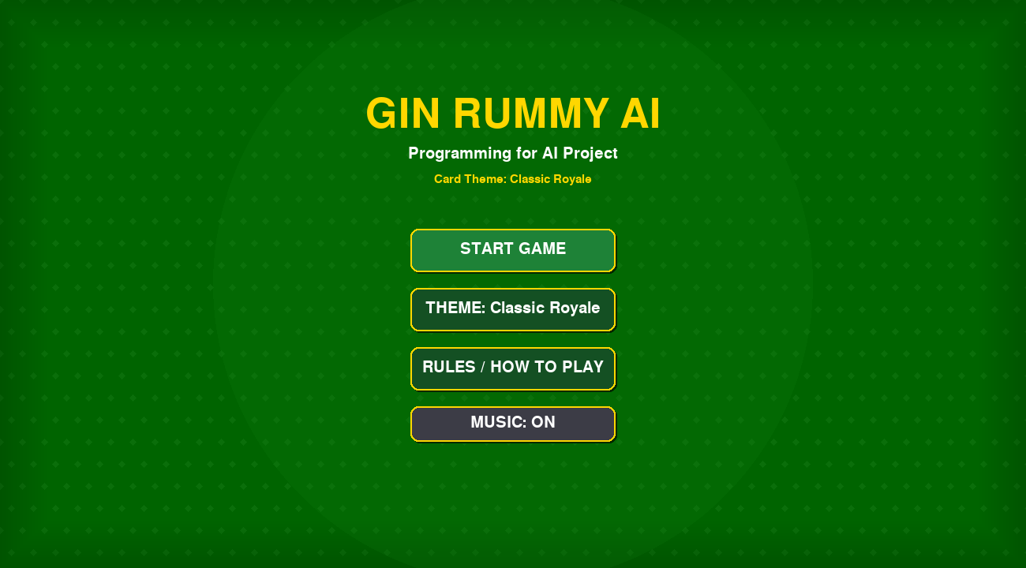
Figure 1: Main menu
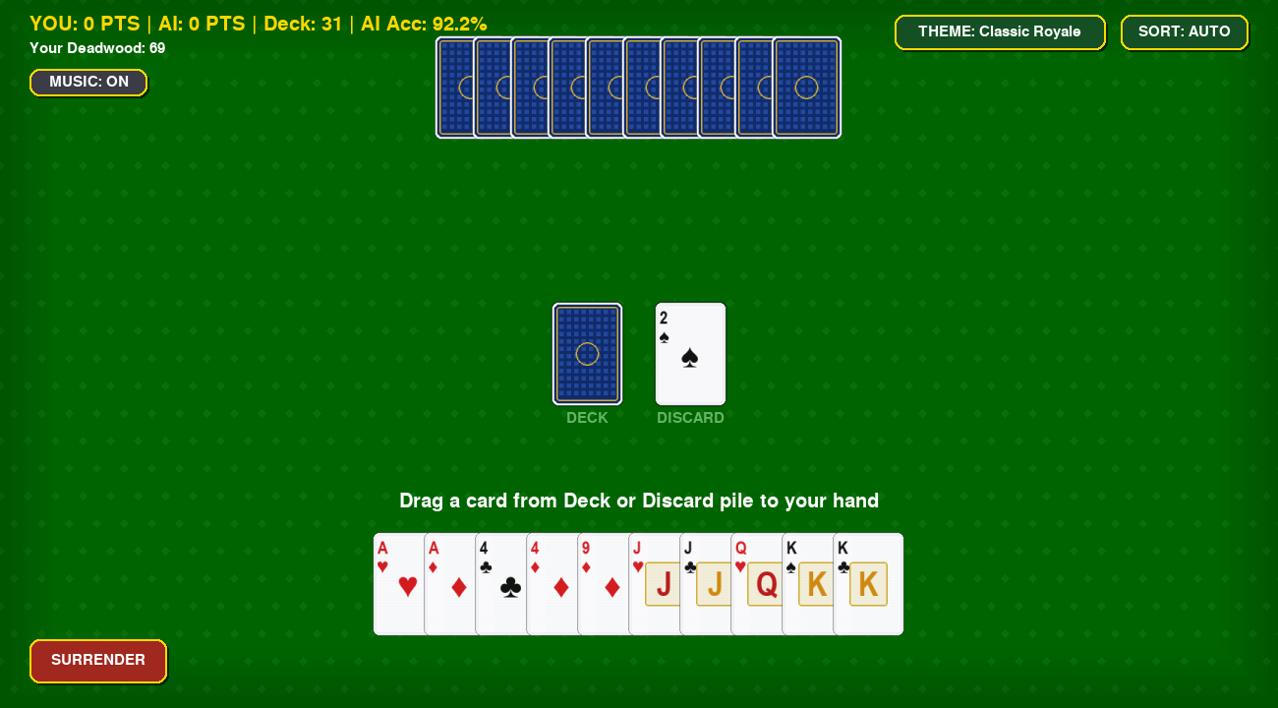
Figure 2: Game table at the start of a round (10 cards each, 31 cards left in the deck)

5. Testing & Results

Unit Tests
test_game.py contains 19 unit tests. We ran the file for this report and all 19 passed.
Group | Tests | What is checked
Deck basics | 3 | 52 unique cards, shuffling, reset
Deck recycling | 2 | Discards go back into an empty deck; the AI hand stays at 10 cards when the deck is empty
Melds and deadwood | 5 | Pure sets, pure runs, best meld choice, ace and face-card values, a 10-card gin hand
Knocking and scoring | 3 | Gin bonus of 25, undercut bonus of 25, illegal knock is rejected
AI behaviour | 2 | The AI never discards a melded card; it takes a discard that extends a run
Hand sorting | 4 | Rank, runs and sets sorting; the sort mode cycles correctly

Model Accuracy
evaluate_models.py trains each forest on the first 80% of its CSV file and tests it on the remaining 20%. Results are below.
Draw model
Model | Accuracy | Precision | Recall | F1
Random Forest | 97.5% | 95.3% | 88.7% | 91.9%
Always take from deck | 84.0% | — | — | —
Take if deadwood drops | 85.0% | — | — | —

Discard model
Model | Accuracy
Random Forest | 97.2%
Highest card rule | 86.6%
Random guess | 49.7%
Lowest deadwood rule | 39.8%

Accuracy for the discard model is counted per card, and only about one card in eight is labelled as the best discard, so a high accuracy is easier to reach than it looks. The baselines here are simple rules on single columns of the test data, so they are not the same as the greedy player used in the game simulation below.
Knock / gin model
Model | Accuracy | Balanced accuracy | Macro F1
Random Forest | 83.2% | 66.9% | 64.2%
Always knock | 83.3% | 66.7% | 63.6%

This is the hardest of the three decisions. Knock is the correct label in roughly 82% of the rows, and the forest ends up almost level with the “always knock” baseline.
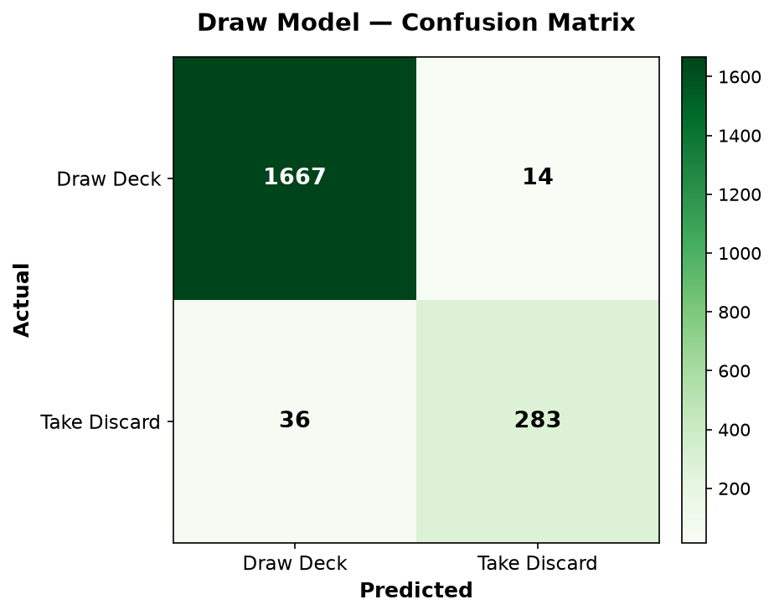  Draw model | 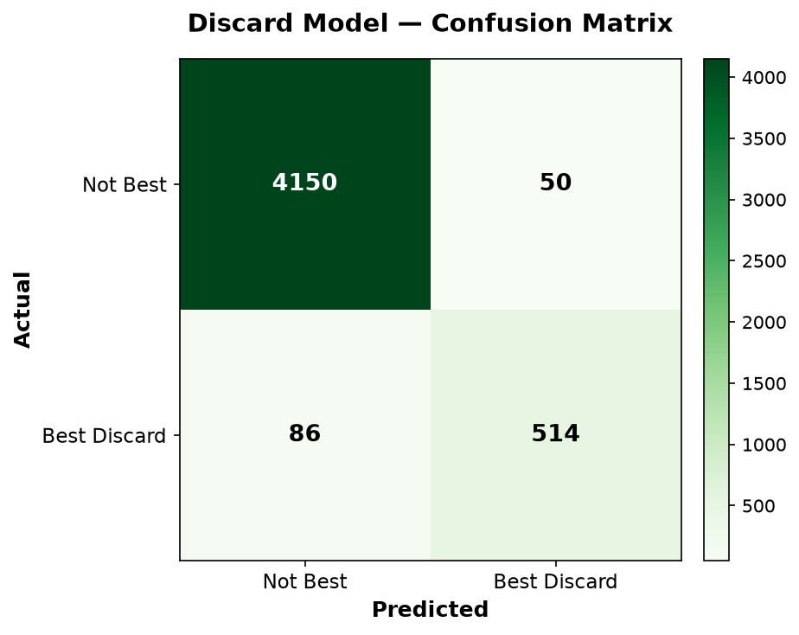  Discard model | 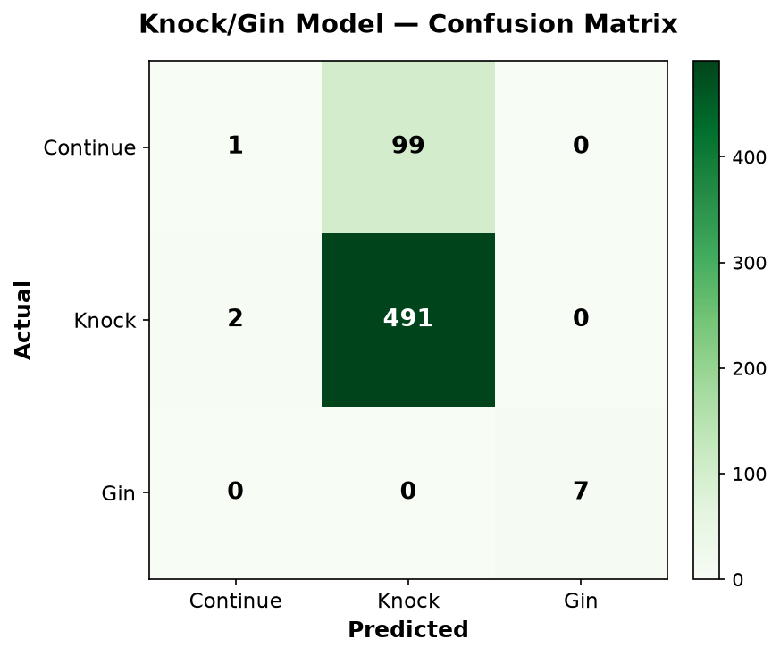  Knock/gin model
Figure 3: Confusion matrices

Feature Importance
The evaluation estimates which inputs matter most for each model. For the draw model, deadwood_gain_if_take dominates, followed by discard_top_number and top_same_number_in_hand. For the discard model, deadwood_after_discard and deadwood_reduction matter most, and card_number also counts because face cards are worth 10. For the knock model, my_deadwood is the strongest feature, with gin_chance_next_draw and deck_size behind it.
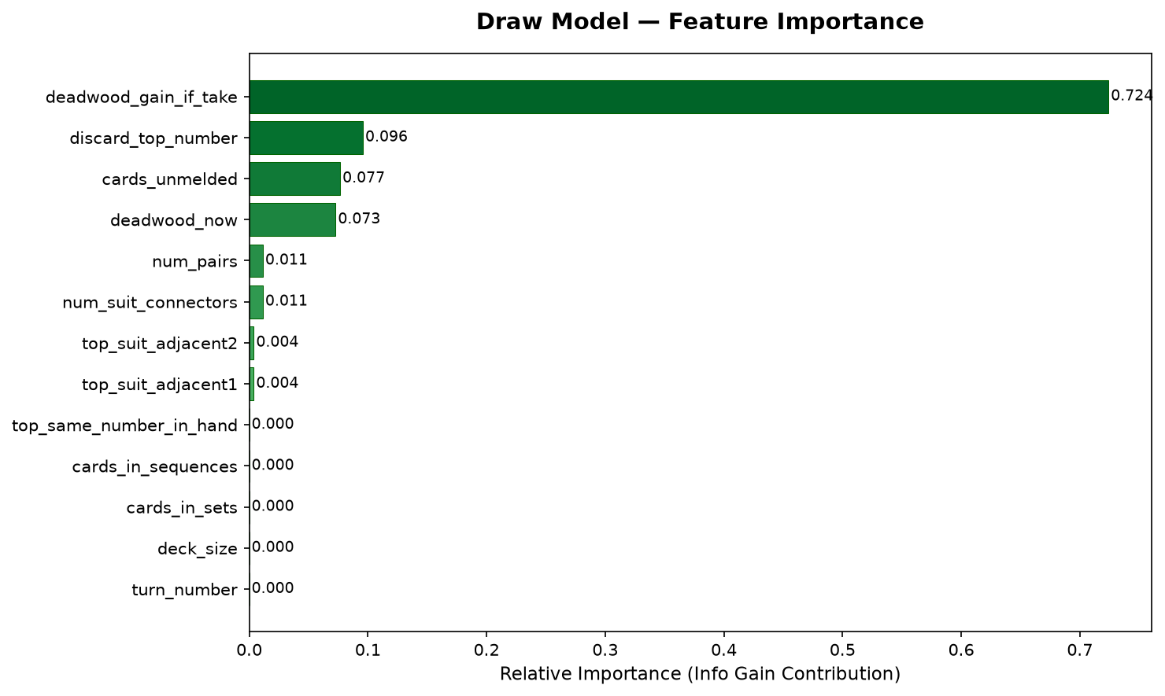
Figure 4: Draw model feature importance
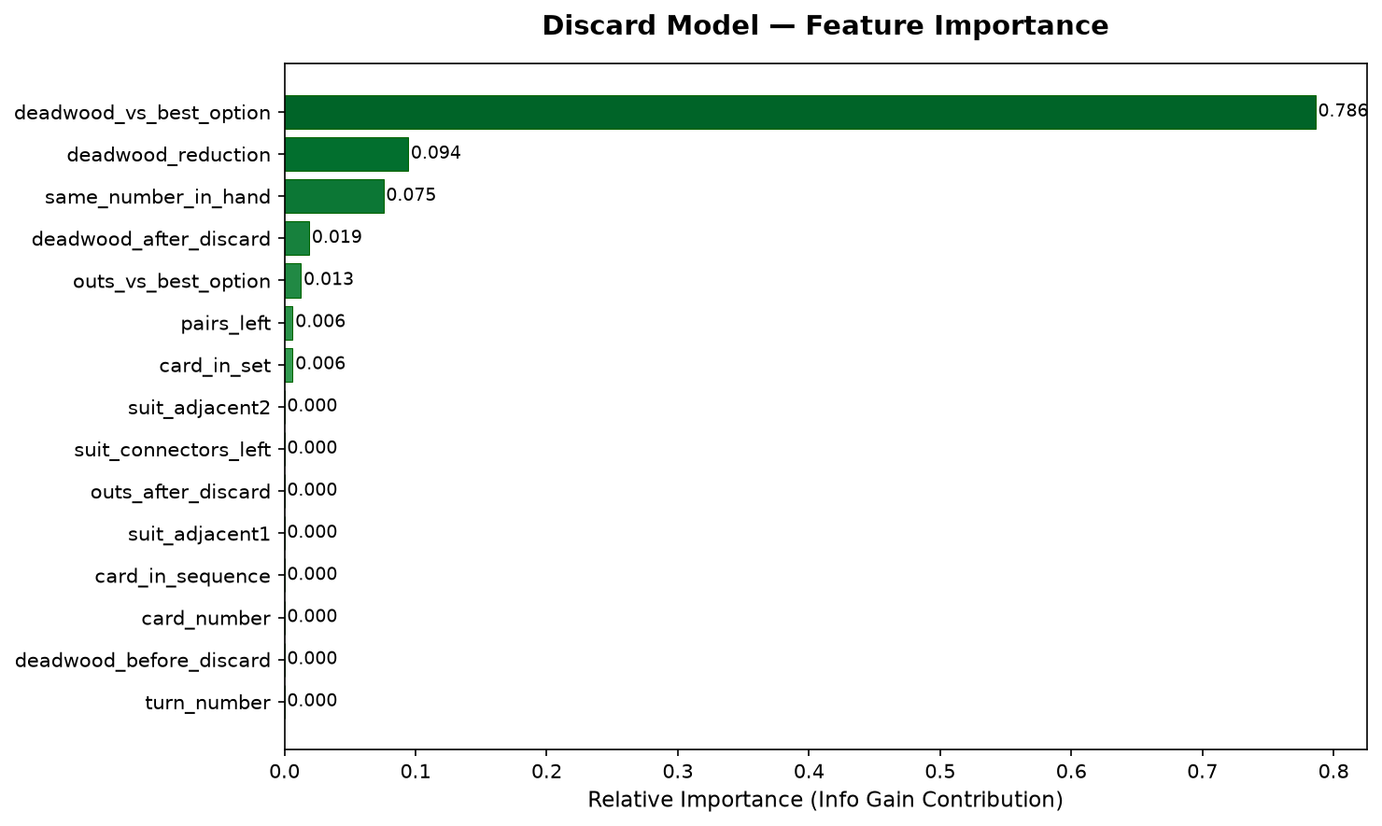
Figure 5: Discard model feature importance
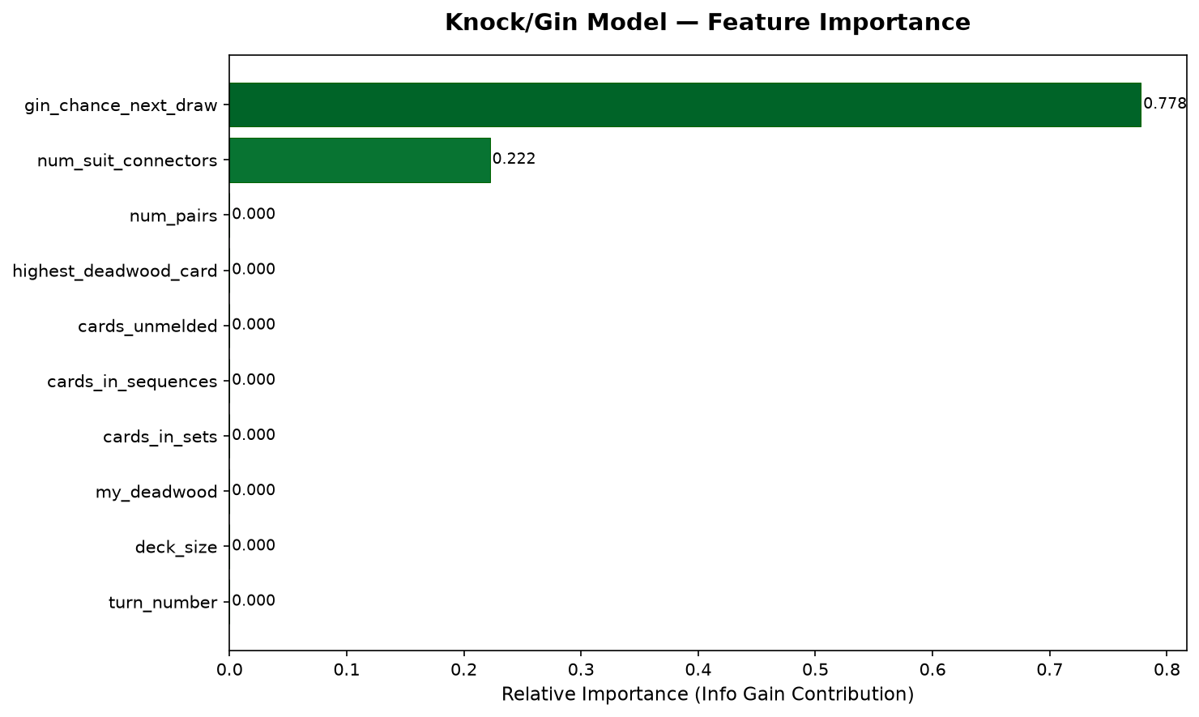
Figure 6: Knock/gin model feature importance

Win-Rate Simulation
The AI played 1,000 full games against each baseline. The random player draws and discards at random and never knocks. The greedy player always minimises deadwood and knocks whenever it can.
Metric | AI vs Random | AI vs Greedy
AI wins / opponent wins / draws | 999 / 1 / 0 | 526 / 474 / 0
AI win rate | 99.9% | 52.6%
Average AI deadwood | 6.7 | 14.5
Average opponent deadwood | 58.5 | 16.7
Average turns per game | 8.1 | 6.5

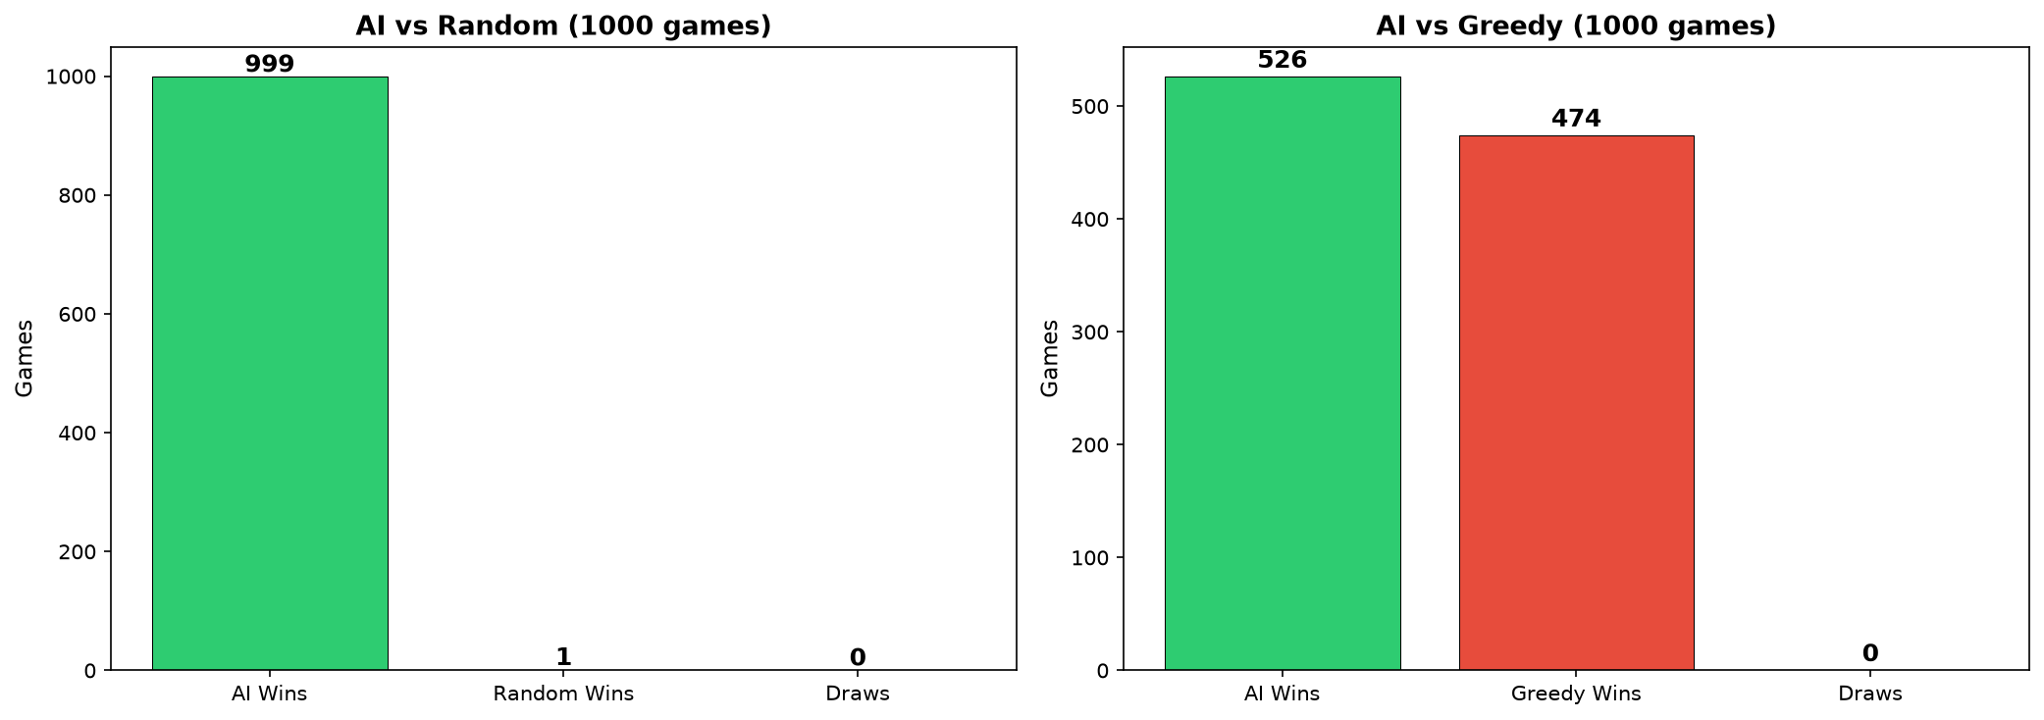
Figure 7: Win rate of the AI against both baselines
The AI is far ahead of the random player. Against the greedy player the edge is small, so it is better described as roughly equal with a slight lead than as a clear win.

6. Conclusion, Limitations & References

Conclusion
The project delivers a playable Gin Rummy game with card graphics, drag and drop controls, scoring and an AI opponent. The Random Forest and ID3 code were written by us, the training data was generated from the game’s own rules, and the AI was tested against two baselines. The draw and discard models learn their tasks well on the test data. The knock model gives almost no gain over a simple rule, and in full games the AI only slightly beats a greedy player, which we report as it is.

Limitations
- Rules are simplified: there are no layoffs, and card values follow the code.
- Labels come from simulated look-ahead, not from expert human play.
- Each decision is made one move at a time. The AI does not plan several turns ahead and does not track which cards the opponent has picked up.
- The knock model barely improves on the “always knock” baseline.
- The AI also depends on fixed rules and a scoring formula, so its play is not purely from the models.
- When it trains by itself, the game uses only 2,000 rows per dataset, and no systematic hyperparameter search was done.
- The AI was tested against bots only. Its strength against skilled human players is not measured.
- There is no online multiplayer.

Future Enhancements
- Search for better tree count and depth settings.
- Train the in-game models on the full datasets.
- Add opponent tracking so the AI can use the cards the other player has taken.
- Test the AI against human players.

References
- Pygame documentation: https://www.pygame.org/docs/
- NumPy documentation: https://numpy.org/doc/
- Pandas documentation: https://pandas.pydata.org/docs/
- Breiman, L. (2001). Random Forests. Machine Learning, 45(1), 5–32.
- Gin rummy rules (Wikipedia): https://en.wikipedia.org/wiki/Gin_rummy
- CuteCards asset pack by Dani Maccari (card images): https://dani-maccari.itch.io/

